**Assignment 3 Advance Image Processing**

**Seam Carving**

**Dewi Kharismawati**

**14231619/dek8v5**

## Implementation

There are multiple ways to resize an image. 2 common ways are rescaling by interpolation and cropping. Rescaling suffers from losing details and information of the image, while cropping has a risk to crop important information. Therefore, we are introducing seam-carving. Content aware image resizing technique that able to change width and height of an image intelligently considering the importance of each pixel by calculating its energy. Low energy area is less interesting, and we will remove these pixels from the image.

*Pseudocode*

*Read image*

*Initialize edge energy for each pixel $e\left(i,j\right)=\left|\frac{∂I(i,j)}{∂i}\right|+\left|\frac{∂I(i,j)}{∂j}\right|$ where*

$$\frac{∂I\left(i,j\right)}{∂i}≈\left(I\left(i,j\right)-I\left(i,j-1\right)\right)$$

$$\frac{∂I\left(i,j\right)}{∂y}≈(I\left(i,j\right)-I(i-1,j)$$

*Compute minimum energy M and its min path P for all possible connected seams and*

$$M\left(i,j\right)=e\left(i,j\right)+min⁡(M\left(i-1,j-1\right), M\left(i-1,j\right),M\left(i-1,j+1\right))$$

$P(i,j)$*= -1 (left) or 0 (up) or 1 (right)*

*Trace back the minimum path from the minimum energy of the last row (for vertical) or the last col (for horizontal) and trace back to row=1 or col=1.*

*Remove the pixel along that path with minimum energy*

*Iterate until max iterations desired.*

In this assignment, the direction of the carving can be vertical, horizontal, v_h (vertical then horizontal), and h_v (horizontal then vertical). We will compare.

Result 1 Vertical carving 1 time

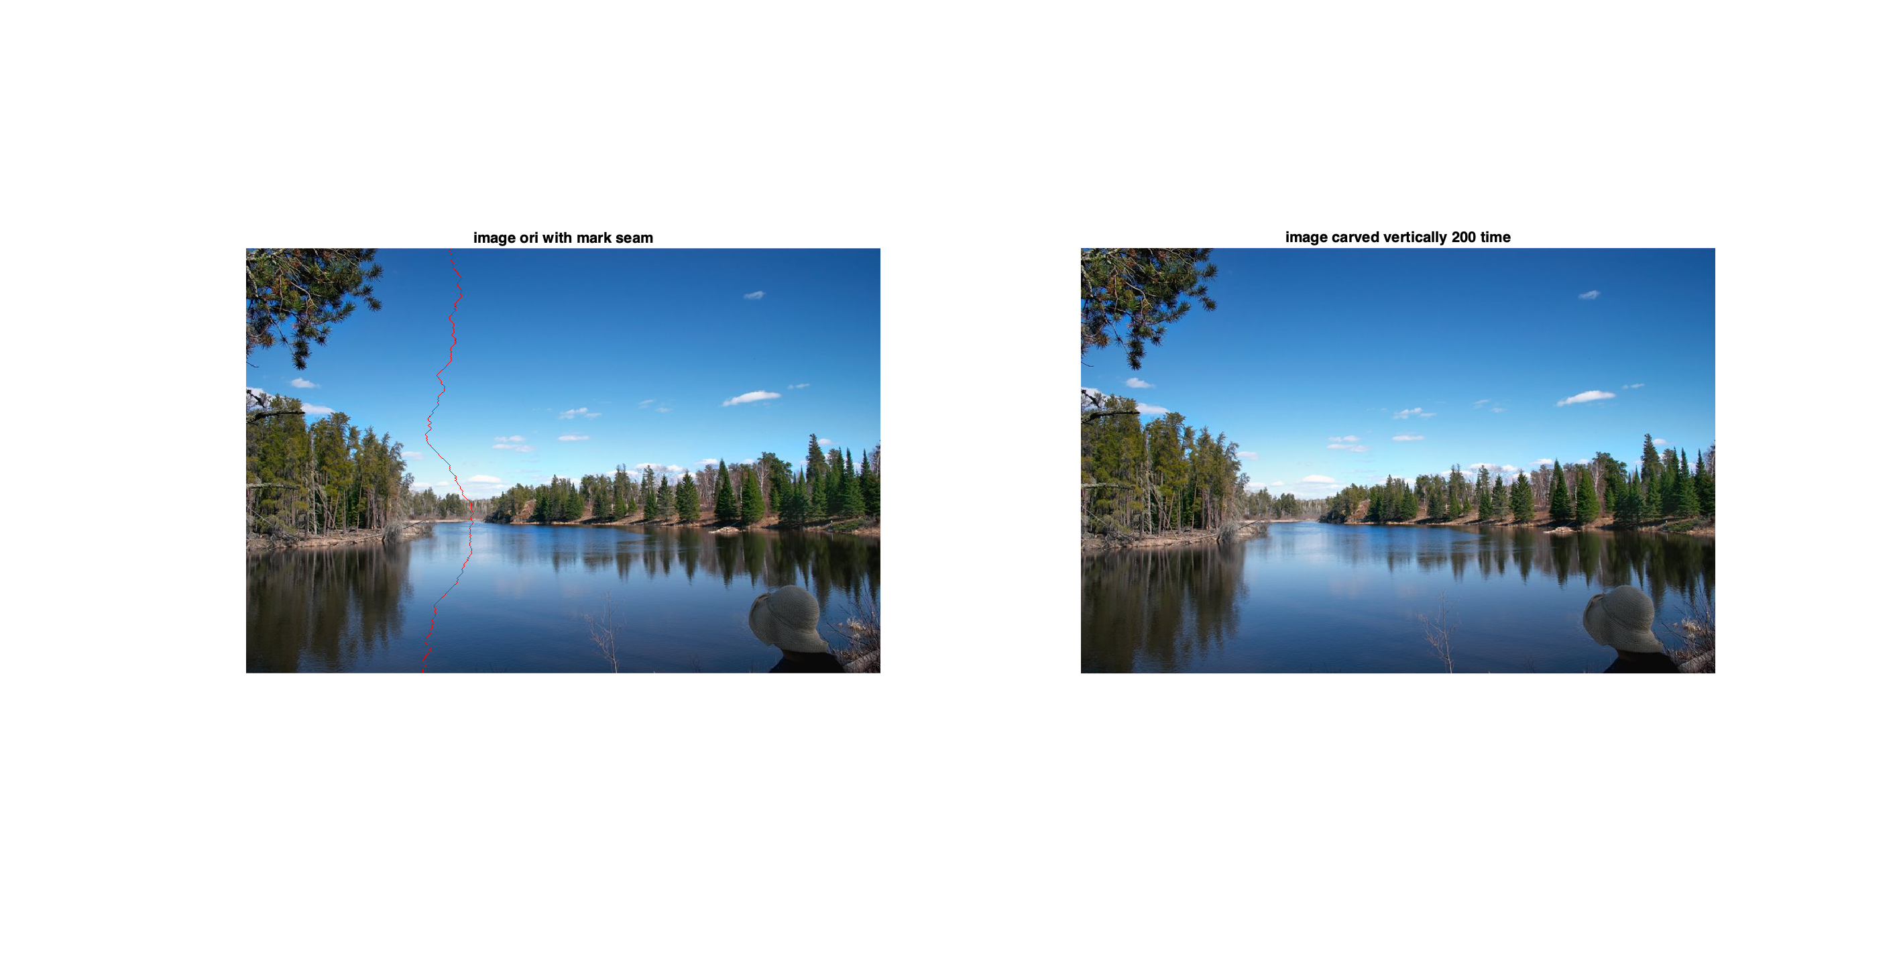

Elapsed time is 0.696545 seconds.

Result 2 – Horizontal carving 1 time

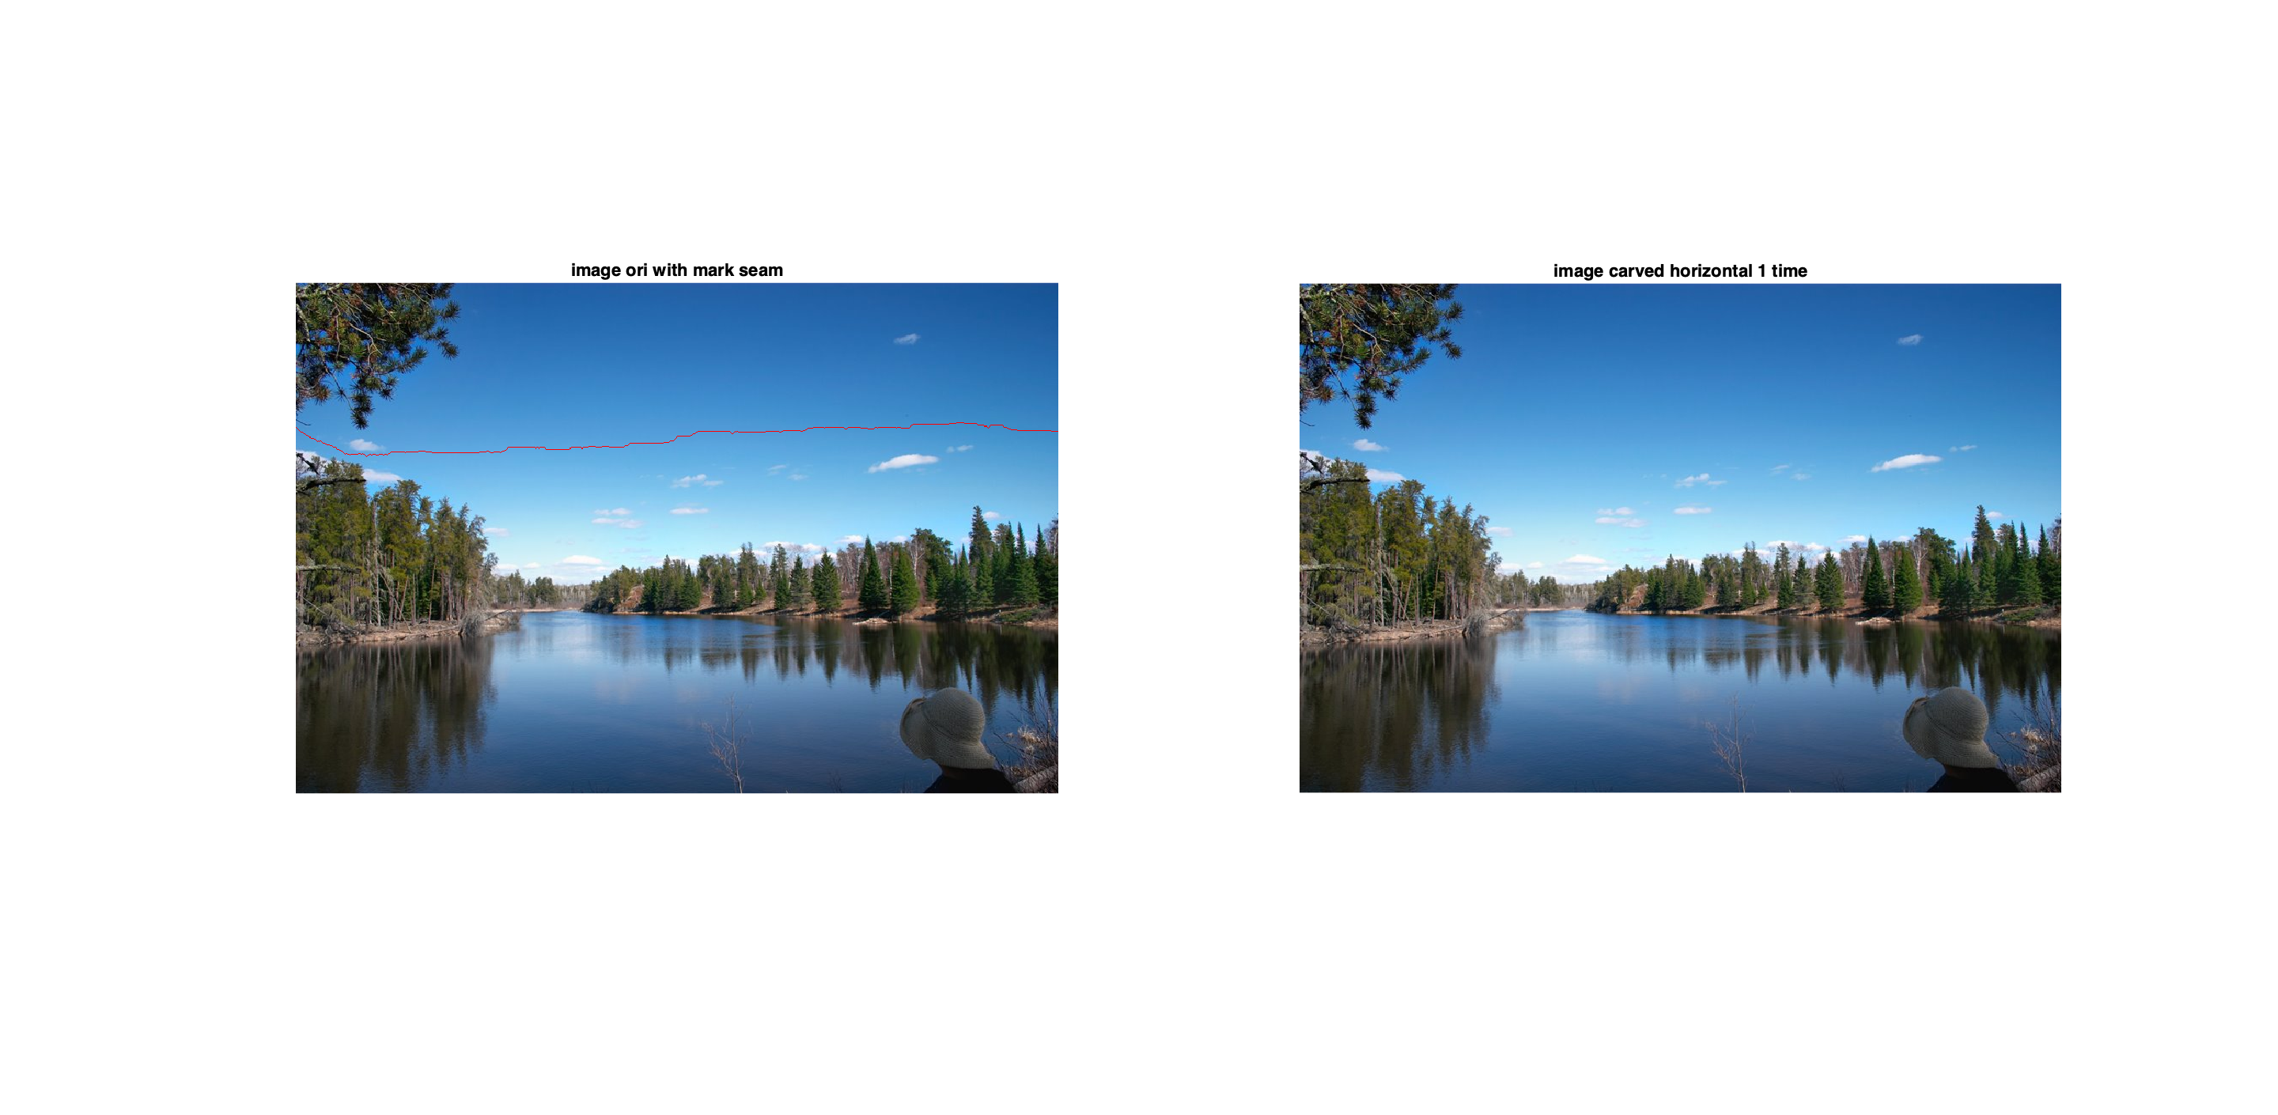

Elapsed time is 0.712554 seconds.

Result 3 – vertical carving 200 times

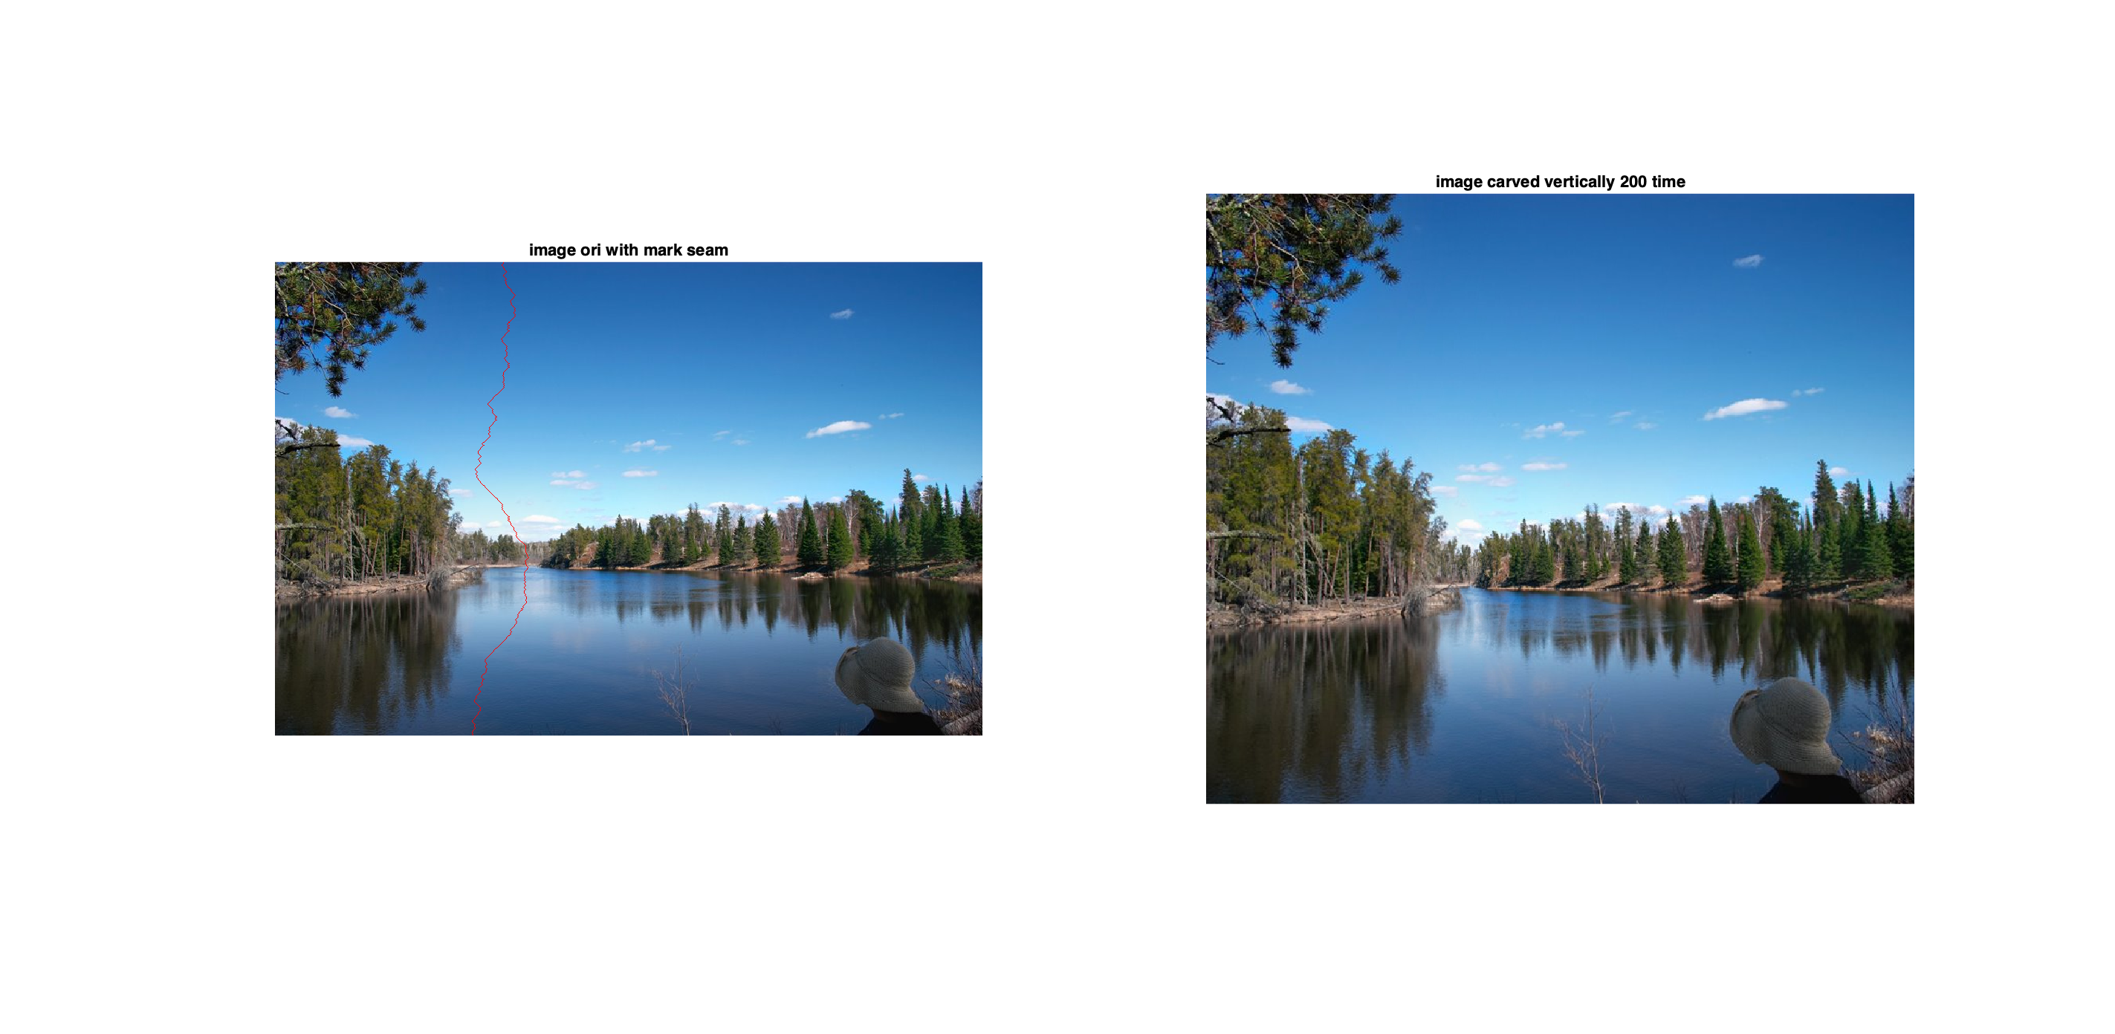

Elapsed time is 122.535591 seconds.

Result 4 – Horizontal Carving 200 times

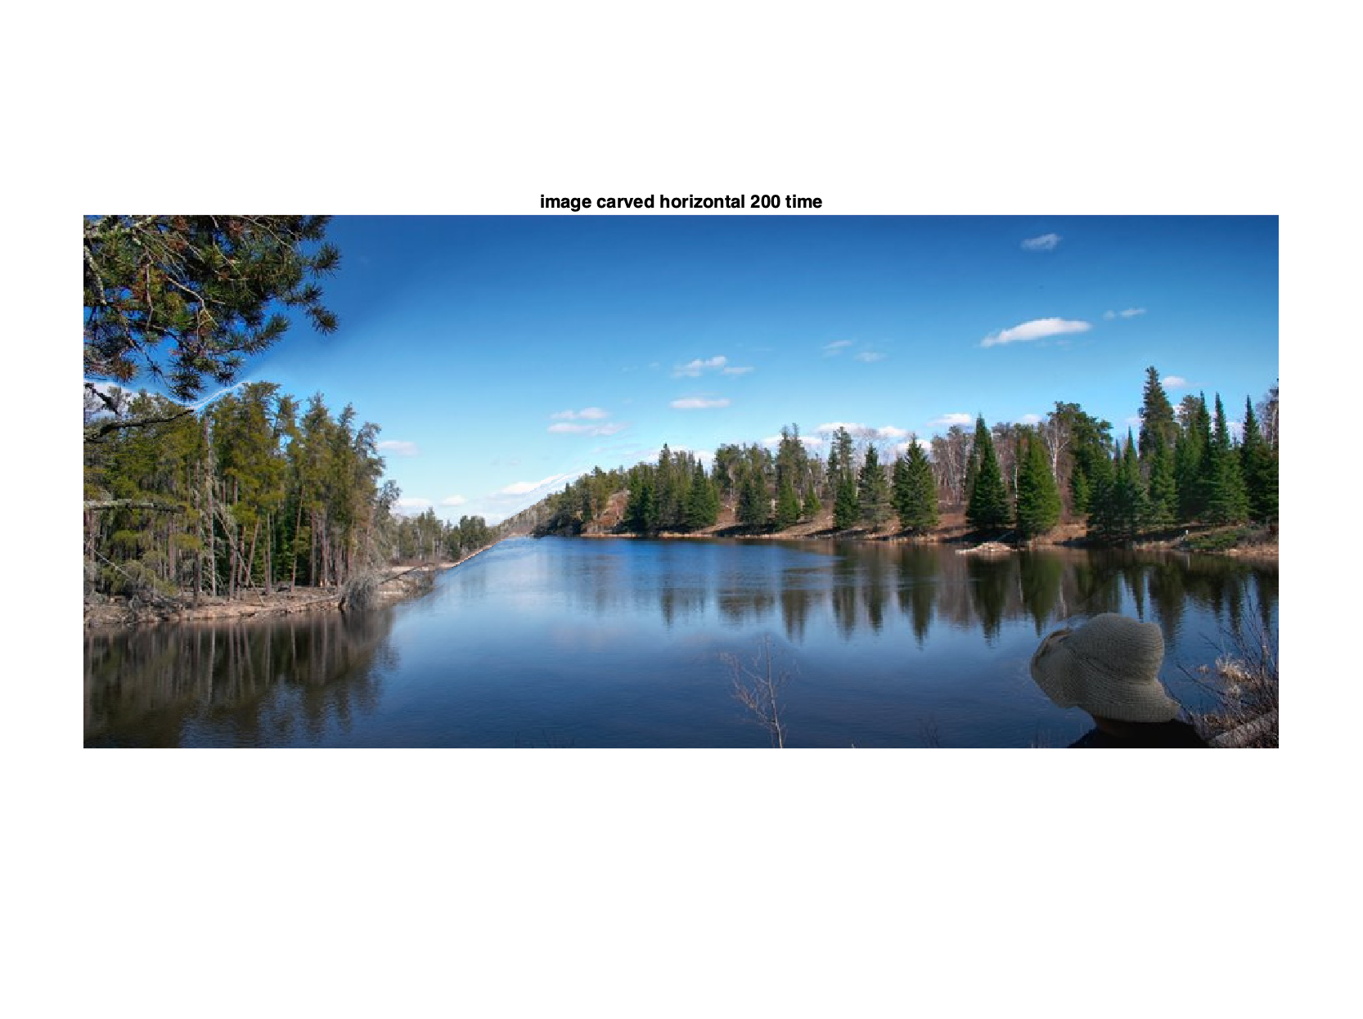

Elapsed time is 113.304626 seconds

Result 5 – vertical carving 200 then horizontal carving 200 iterations (400 iterations in total)

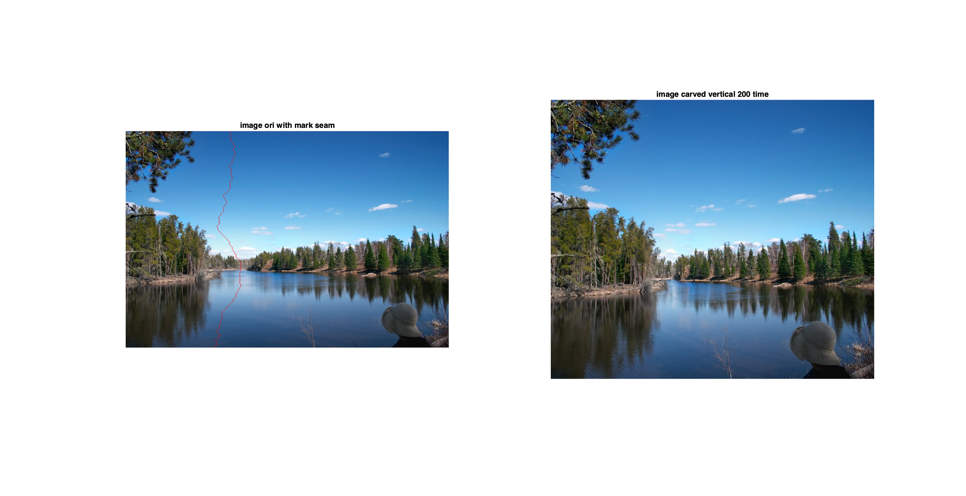

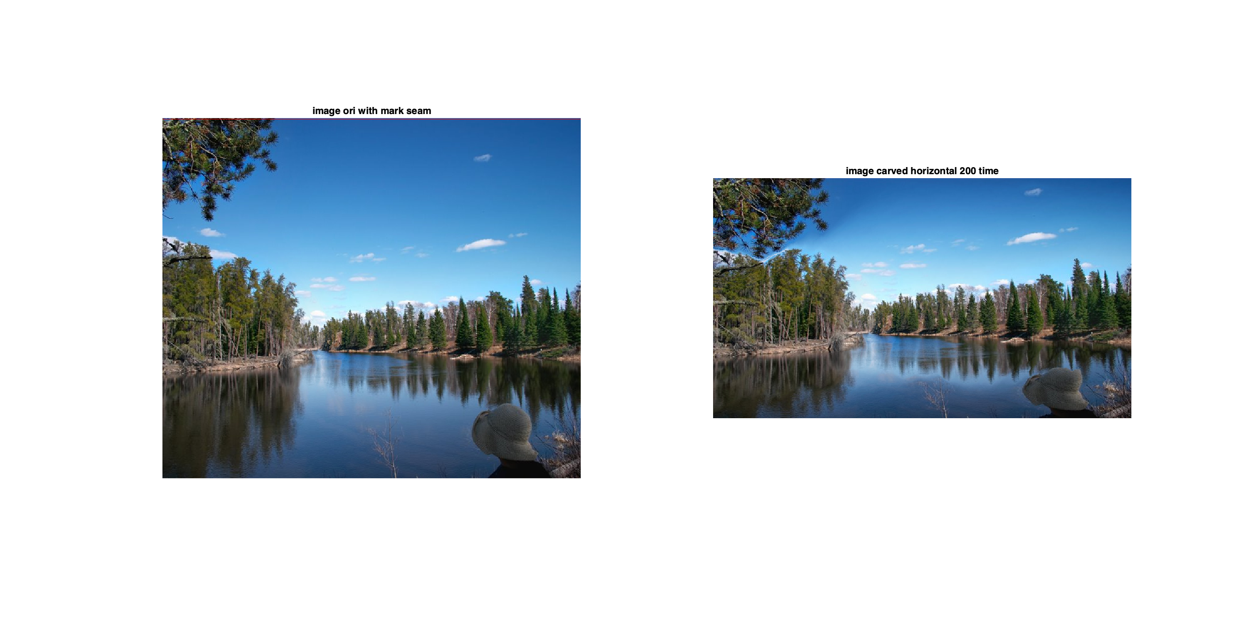

Elapsed time is 211.187724 seconds.

Result 6 – horizontal carving 200 iterations then vertical carving 200 (400 iterations in total)

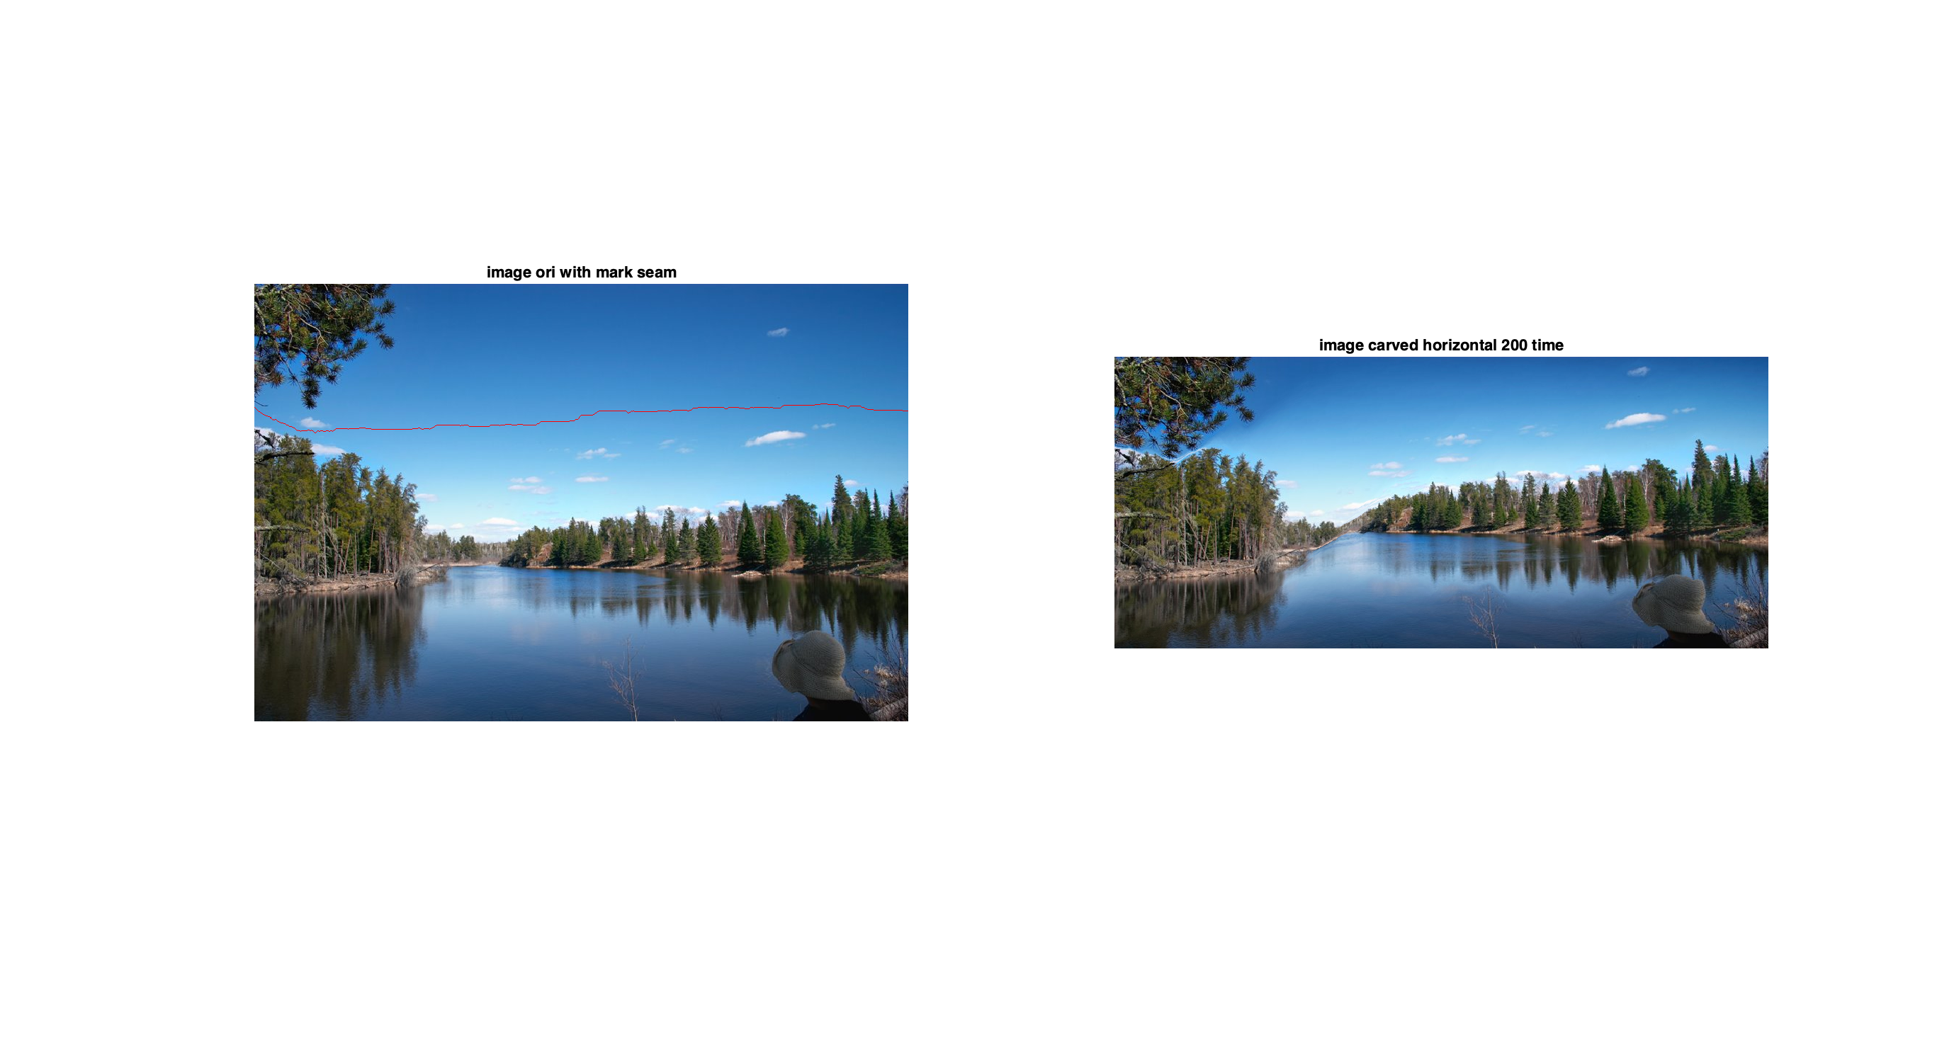

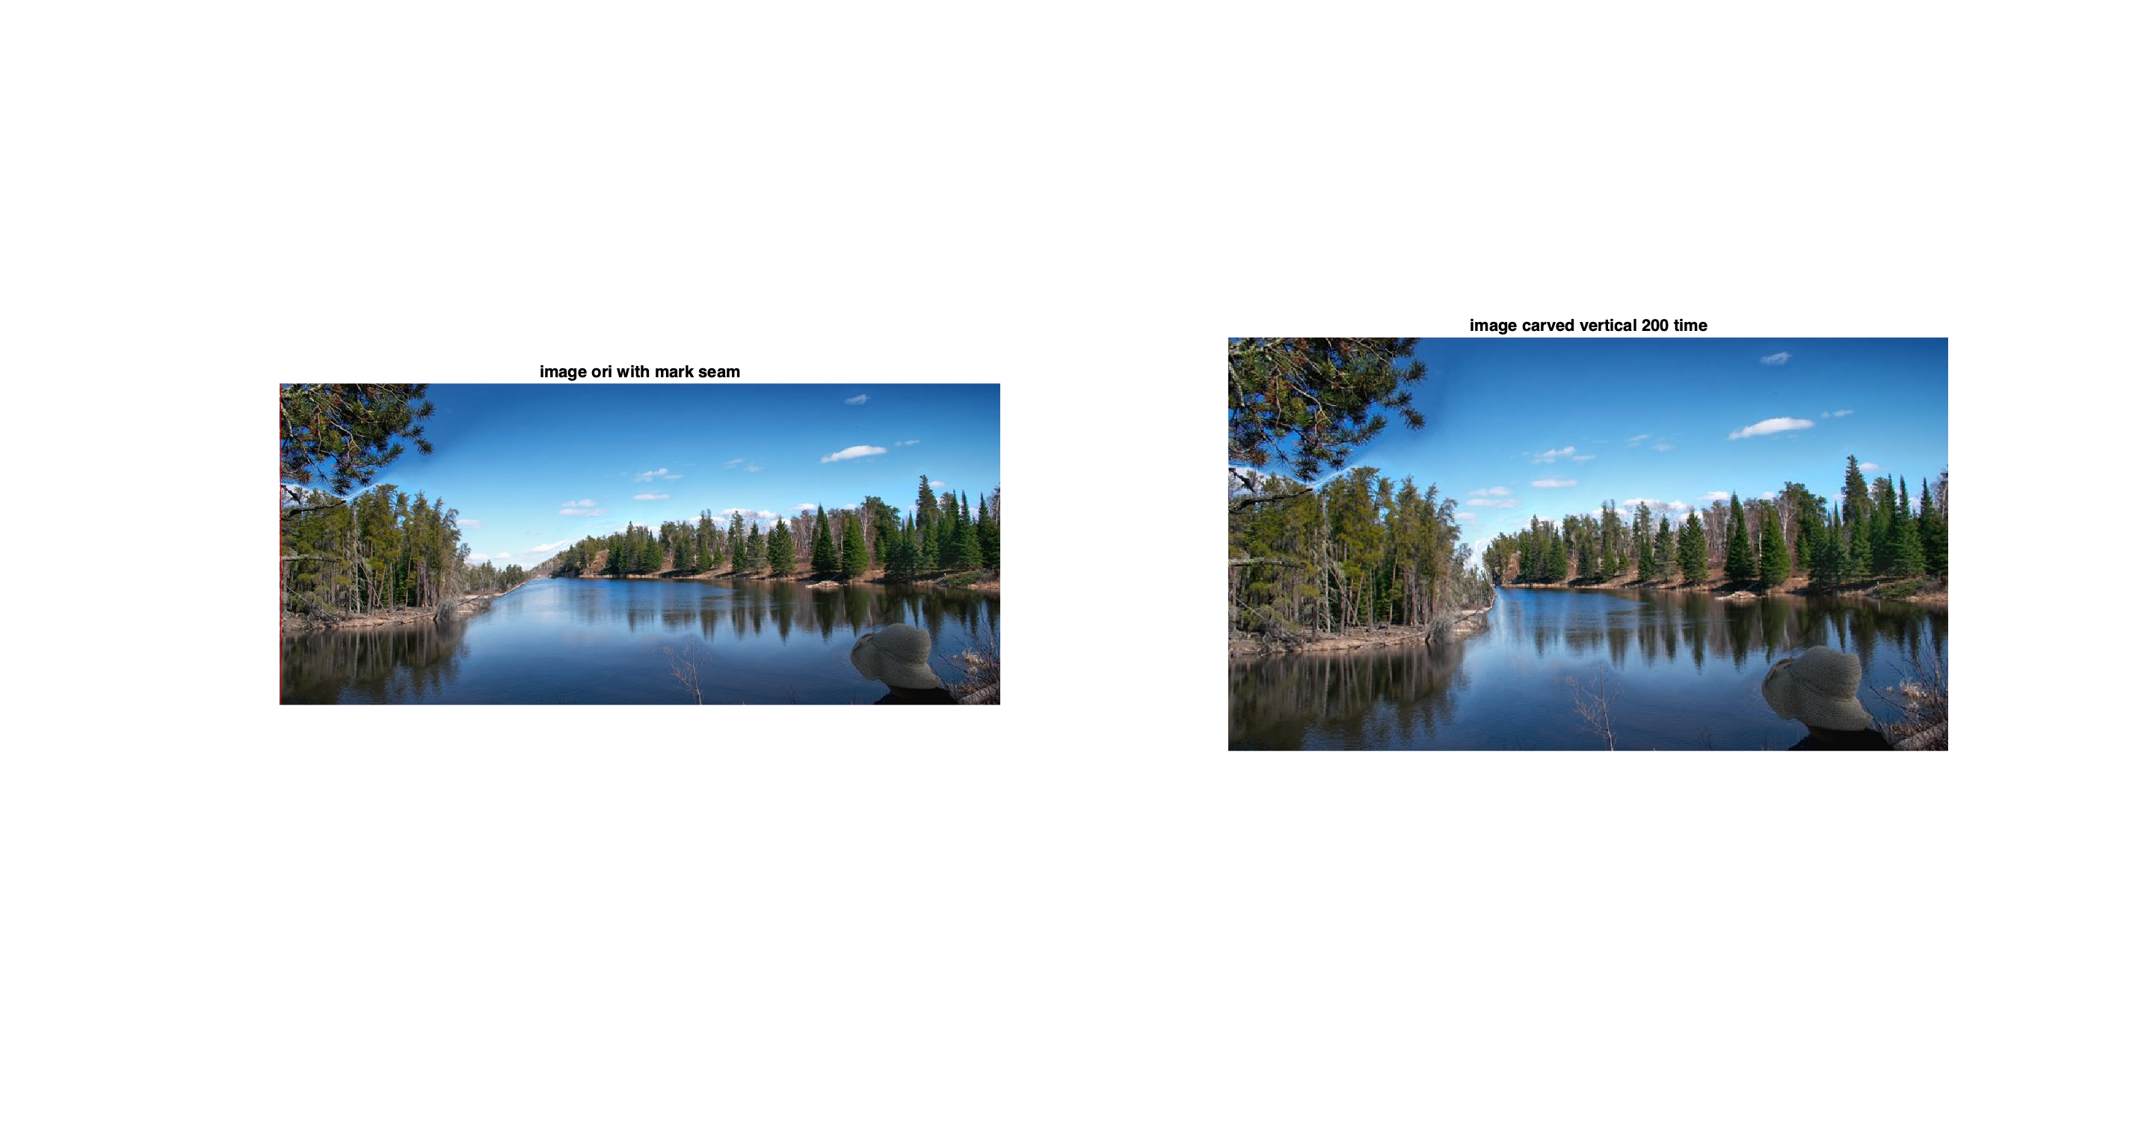

Elapsed time is 220.627814 seconds.

Conclusion

The most important finding is the difference between horizontal and vertical carving. In this particular image, landscape, the result is better when we seam-carve vertically. There are a lot of trees, which more make sense if we carve it vertically. In horizontal mode, there are some wiggle that noticeable in the border between land and water in the middle. It seems less natural.

Another important finding is that when we do vertical then horizontal compare to horizontal then vertical seam carving. Based on result 5 and 6, vertical then horizontal resize the image really well. It is smooth and hard to spot which path deleted. Whereas in result 6 we can see some flaw on the water and hill. Therefore, before do seam carving, we better understand the type of our image, so that the resizing can be smoother and more natural. Therefore, Seam carving is able preserved details and important information when resizing and image. Timewise, it requires around 220 seconds to carve 400 iterations. Which I think it is good and worth the result that we are getting.